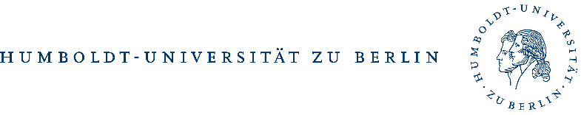
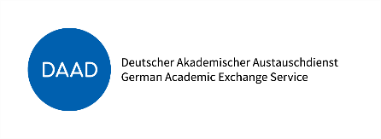
with financial support from

IN// RCSD MASTER CLASS 2022
APPLICATION FORM
APPLICANTS DETAILS:
- First Name/s:
- Surname:
- Age:
- Gender:
- Citizenship:
- Email Address:

- Any disability we should be aware of (so that we may take care of your needs as best as we can):
NO ☐ YES ☐
If ‘YES’, please specify:

- Any food allergies/requirements:
(E.g., Lactose Intolerant, Halaal, Kosher, Vegetarian, Abstain from beef, pork, fish etc.).

- Name of the University you are currently registered at:

- Discipline/Subject:

- MA ☐ PhD ☐

SDG SELECTION
(TO BE FILLED BY MASTERS STUDENTS ONLY)
Which of the following Sustainable Development Goal’s would you be interested in researching at the IN//RCSD Master Class?
Please click on the box provided. Please select only TWO of the following options:

☐ Goal 1: No Poverty
☐ Goal 2: Zero Hunger
☐ Goal 3: Good Health and Well Being
☐ Goal 4: Quality Education
☐ Goal 5: Gender Equality
☐ Goal 6: Clean Water and Sanitation
☐ Goal 7: Affordable and Clean Energy
☐ Goal 8: Decent Work and Economic Growth
☐ Goal 9: Industry, Innovation, and Infrastructure
☐ Goal 10: Reduced Inequalities
☐ Goal 11: Sustainable Cities and Communities
☐ Goal 12: Responsible Consumption and Production
☐ Goal 13: Climate Action
☐ Goal 14: Life Below Water
☐ Goal 15: Life on Land
☐ Goal 16: Peace, Justice, and Strong Institutions
☐ Goal 17: Partnerships for the Goals

DAAD SUMMER SCHOOL PROPOSED RESEARCH QUESTION
(TO BE FILLED BY MASTERS STUDENTS ONLY)
Please outline a preliminary research question for a small empirical field work project related to the topic of religious communities and sustainable development to be conducted during the IN//RCSD Master Class.

Research Question:

PhD DISSERTATION TOPIC
(TO BE FILLED BY PHD’S ONLY)
Provide a 1-page outline of your dissertation topic. Please provide the following information: title, rationale for research, theoretical framework, and methodological approach. PhD students will be asked to prepare a poster of their dissertation topic (before the start of the Master Class) to be presented during IN//RCSD Master Class.
Title:

Rationale for research:

Theoretical Framework:

Methodological Approach:

CHECKLIST
Please ensure that all details are correct. Please include the following documents in your submission:
- ☐ Application Form
- ☐ CV
- ☐ Motivational Letter
(The motivational letter should include your prior exposure to or experience with the academic or practical field of religion and development, your motivation to participate in this Master Class, and your personal research interest in this field. Please also state how the participation in the IN//RCSD Master Class will benefit your future studies or career.)
- ☐ Copy of Valid Student ID
- ☐ Copy of Valid ID/ Passport

Send application in ONE COMBINED PDF DOCUMENT to:
Ms. Nora Monzer network.rcsd@hu-berlin.de
DEADLINE: 31 MAY 2022

*Please note that preference will be given to students currently researching/studying religious communities and sustainable development.

Applications with any documents missing will NOT be accepted.
Inquiries: Ms. Nora Monzer network.rcsd@hu-berlin.de

